Regarding Differential evolution algorithm

Differential evaluation (DE) is used for hall effect sensor optimization with multi-objective design optimization. In this study, the differential evaluation (DE) optimization technique is used to search the design space by 2D finite element analysis (FEA) evaluation given predefined machine variables as in Table. I.

A multi-objective function (MO) in Table. II is used for calculating the cost of each design. $O_{m}$ are objective variables, and $w_{m}$ is weighting factors. The goal is to minimize the cost of the MO function. The penalty is used for eliminating designs that either violate the geometric constraints outside the input range shown in Table I.

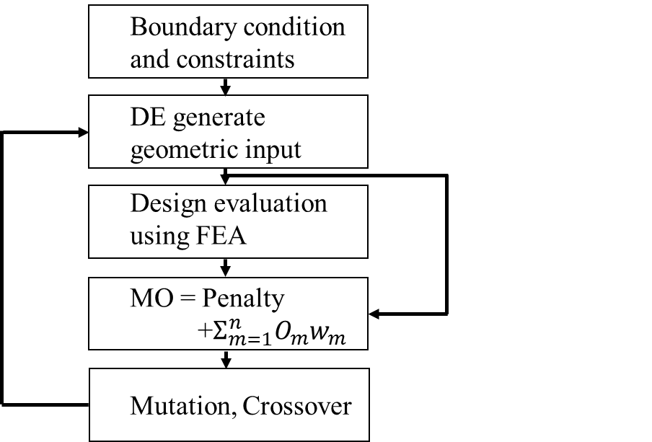

Fig. 1 FEA based optimization using DE.

Regarding the Resolver model used

Fig. 2 and Table I. summarize the input variables and their maximum, minimum, and initial values. Fourteen variables are used to define the hall effect sensor based resolver. Among the fourteen variables, nine variables, which are with minimum and maximum values, are used for the geometry. Hall sensors A and B are placed in the airgap aligned to d and q-axes. M-19 is used for both stator and yoke with varying PM material from sintered NdFeB, Bonded NdFeB, and Ferrite.

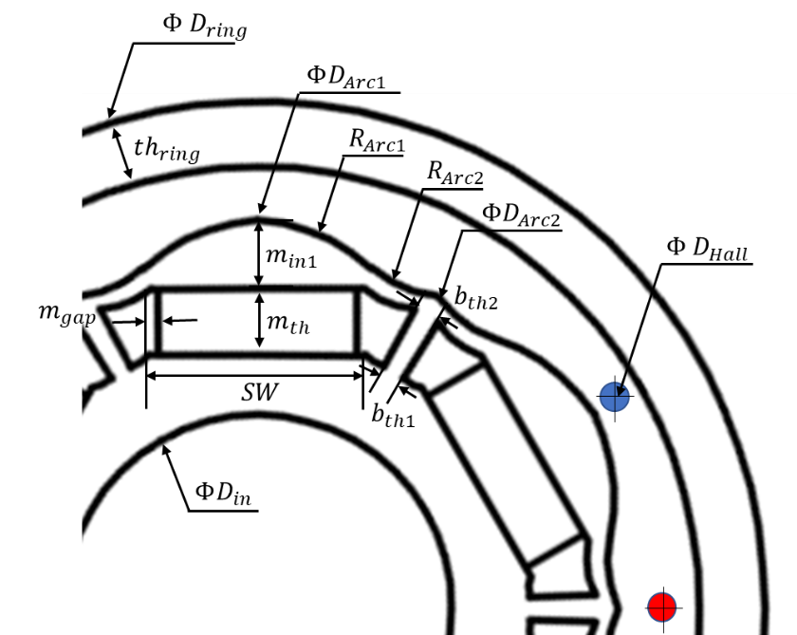

Fig. 2 Resolver model and Hall sensors

|  |  |  |  |  |  |
| --- | --- | --- | --- | --- | --- |
| Symbol | Meaning | Unit | Min. value | Max. value | Initial value |
| $$ΦD_{Arc1}$$ | Rotor d-axis outer diameter | mm | - | - | 36.0 |
| $$ΦD_{Arc2}$$ | Rotor q-axis outer diameter | mm | 30.6 | 34.2 | 34.2 |
| $$Φ D_{Hall}$$ | Hall sensor placed diameter | mm | - | - | 38.0 |
| $$ΦD_{in}$$ | Rotor inner diameter | mm | - | - | 18.0 |
| $$Φ D_{ring}$$ | Ring outer diameter | mm | - | - | 47.0 |
| $$ring_{th}$$ | Ring thickness | mm | - | - | 3.0 |
| $$R_{Arc1}$$ | Rotor d-axis outer arc | deg. | -40.0 | 100.0 | 50.0 |
| $$R_{Arc2}$$ | Rotor q-axis outer arc | deg. | -40.0 | 40.0 | 20.0 |
| $$m_{th}$$ | Magnet thickness | mm | 1.0 | 3.0 | 1.5 |
| $$m_{in1}$$ | Magnet distance from $ΦD_{Arc1}$ | mm | 1.0 | 5.0 | 2.0 |
| $$m_{gap}$$ | Magnet gap in slot | mm | 0.3 | 3.0 | 0.8 |
| $$SW$$ | Slot width | mm | 7.0 | 11.0 | 8.0 |
| $$b_{th1}$$ | Outer bridge thickness | mm | - | - | 1.0 |
| $$b_{th2}$$ | Inner bridge thickness | mm | 1.0 | 2.0 | 1.5 |

Table. I Input variables for resolver based on the Hall effect sensor.

Regarding Objective function used

This investigation explores the suitability of various objective functions to evaluate hall effect sensor based resolver designs based on the following key performance parameters: Total Harmonic Distortion (THD), Fundamental amplitude of the airgap flux density, Permanent Magnet (PM) volume. Objective functions, $O_{n}$, are defined as in Table. II with weighting factors, $w_{n}$.

|  |  |
| --- | --- |
| $$MO=Pennalty+\sum_{n=1}^{3}{O_{n}w_{n}}$$ | (1) |

|  |  |  |
| --- | --- | --- |
| Symbol | Function | Meaning |
| $$O_{1}$$ | THD | Total harmonic distortion of flux in % |
| $$O_{2}$$ | $${\left(B_{Hall}-0.08\right)}^{2}$$ | Fundamental flux amplitude in Tesla with target amplitude of 0.08 |
| $$O_{3}$$ | PM Volume | Magnet volume in ${mm}^{3}$ |
| $$w_{1}$$ | 20 | Weighting factor of $O_{1}$ |
| $$w_{2}$$ | 20000 | Weighting factor of $O_{2}$ |
| $$w_{3}$$ | 10 | Weighting factor of $O_{3}$ |
| Penalty | 0 if within boundary  100 if outside boundary | Penalty given when the input variables are outside the minimum and maximum range. |

Table. II Component of the multi-variable objective function